Spatial Pattern Analysis of Schmidt–Ferguson Climate Classification in Gorontalo Province Based on Rainfall Data

Gifari S Pratama¹, Ahmad Syamsu Rijal S²*, Talha Dangkua², Dewa Oka Suparwata³

¹ Student in Geography Study Program, Universitas Muhammadiyah Gorontalo, Gorontalo, Indonesia.
² Geography Study Program, Universitas Muhammadiyah Gorontalo, Gorontalo, Indonesia.
³ Agribusiness Study Program, Universitas Muhammadiyah Gorontalo, Gorontalo, Indonesia.

Received: February 10, 2026  Revised: March 29, 2026  Accepted: April 25, 2026  Published: April 30, 2026  Corresponding Author:  Ahmad Syamsu Rijal S  ahmadsyamsurijals@gmail.umgo.ac.id  DOI: 10.29303/jppipa.v12i4.14568  Publisher  UPT Mataram University Press    © 2026 The Authors. This article is distributed under a (CC-BY License)  Publisher  UPT Mataram University Press   | Abstract: Climate change has altered rainfall patterns in Indonesia; however, spatially detailed climate classification in Gorontalo Province remains limited. This study aims to identify climate patterns using the Schmidt–Ferguson method combined with spatial analysis. The novelty lies in integrating data consistency testing, quantitative Q index analysis, and GIS-based interpolation to produce spatial climate zoning. This study uses monthly rainfall data from 41 consistent observation stations (out of 48 stations) during 2015–2024, obtained from BWS Sulawesi II and BMKG. Data consistency was tested using the Double Mass Curve method, followed by calculation of the Q index and spatial interpolation using the Inverse Distance Weighting (IDW) method. Results show that rainfall data are highly consistent (R² ≈ 1). The Q index ranges from 7.6 to 119, indicating diverse climate types: very wet (A), wet (B), moderately wet (C), moderate (D), and slightly dry (E). Spatially, wet climates dominate mountainous areas, while relatively drier conditions occur in coastal regions. These findings are applicable for crop calendar planning, irrigation management, and disaster mitigation such as flood-prone and drought-prone zoning. However, the study is limited by uneven station distribution and a 10-year observation period. In conclusion, Gorontalo Province exhibits high spatial variability of climate influenced by topography and geographic location.  Keywords: Climate pattern; Geographic information system; Rainfall; Schmidt–Ferguson

Introduction

Climate change has emerged as a critical global challenge, with profound impacts on regional hydrological systems, particularly in tropical countries such as Indonesia. The effects of climate change are clearly evident across the globe, as climate directly or indirectly influences the global fabric of human life—not only in the natural world but also in the economic, social, and cultural sectors (Yamamoto et al., 2021; Leonard et al., 2024; Gradiyanto et al., 2025). As an archipelagic nation located in the equatorial zone and influenced by the complex interaction between the oceans and the continent, Indonesia is highly vulnerable to climate variability, particularly in terms of rainfall patterns (Hanifa & Wiratmo, 2024; Mulsandi et al., 2024). Recent studies indicate that the occurrence of extreme rainfall associated with the monsoon system is increasing in both frequency and intensity, thereby heightening the risk of hydrometeorological disasters such as floods, landslides, and droughts (Wang et al., 2021; Otto et al., 2023).
Rainfall plays a fundamental role in climate classification, as it reflects the temporal and spatial distribution of water availability in a region (Vijith, 2020; Hidayat et al., 2023). Rainfall is the amount of rain that falls in a specific area, measured on a daily, monthly, and annual basis in millimeters, and influenced by other factors (Ren et al., 2023; Ruqoyah et al., 2023). Variability in rainfall patterns directly affects agricultural productivity, water resource sustainability, and vulnerability to disasters (Chakraborty et al., 2025; Tiwari et al., 2016). Specifically, La Niña is not confined to the Pacific, and its duration is not fixed. Climate anomalies such as La Niña have exacerbated rainfall extremes, leading to unpredictable disaster patterns that challenge conventional planning approaches (Ariska et al., 2024; Suhadi et al., 2023). Without accurate and spatially explicit climate classifications, regional policies risk being ineffective in addressing location-specific climate hazards.
One of the most widely used approaches for climate classification in Indonesia is the Schmidt–Ferguson method, which uses the Q-index to describe the ratio between dry months and wet months. A dry month is a month with rainfall < 60 mm, a wet month is a month with rainfall 60 mm –100 mm, and wet months are those with rainfall > 100 mm (Putranto et al., 2022; Sila et al., 2022; Moontuno et al., 2023). This classification does not include temperature as a factor, as it assumes that temperature variations in tropical regions are very small (Yasa et al., 2022). This method is particularly well-suited for determining dry and wet months in tropical climates due to its simplicity, robustness, and strong relevance to rain-fed agricultural systems (V. Moontuno et al., 2023; Pratama et al., 2023). Additionally, this method provides a practical framework for identifying seasonal patterns that are essential for regional-scale climate analysis.
Gorontalo Province is a region with a complex climate, influenced by diverse topography and strong maritime influences (Olii et al., 2021). Recent observations indicate increasing climate variability in this region, including irregular flooding events that deviate from historical patterns (Maulana et al., 2025; Indrawan et al., 2025). However, existing studies are generally limited to local analyses and fail to integrate validated data from various stations using a spatial approach, resulting in an incomplete understanding of climate variability at the provincial scale.
This study aims to address this gap by presenting a comprehensive and spatially explicit analysis of climate patterns in Gorontalo Province. This study is important because accurate climate classification is essential for optimizing agricultural planning, improve water resource management and identify disaster-prone areas. In regions with high spatial variability, such as Gorontalo, the lack of detailed climate zoning can lead to ineffective mitigation strategies and increased environmental risks.
The novelty of this study lies in the integration of (1) multi-station rainfall data with consistency testing, (2) Schmidt–Ferguson climate classification at the provincial scale, and (3) Geographic Information System (GIS)-based spatial interpolation to generate detailed climate zoning. Unlike previous studies that focus on limited administrative areas, this research provides a more comprehensive and scalable framework for understanding climate variability. This integrated approach not only enhances the scientific robustness of climate classification but also strengthens its practical applicability in regional planning and climate adaptation strategies.

Method

Area Study
The study area in this research is Gorontalo Province, which is located in the northern part of Sulawesi Island, Indonesia. Geographically, Gorontalo Province is located between 0°19′ North Latitude and 1°57′ North Latitude and 121°23′ East Longitude and 125°15′ East Longitude. This province is bordered by Central Sulawesi Province to the south, North Sulawesi Province to the east, and Tomini Bay and the Maluku Sea to the west and north. Gorontalo Province has an area of ​​approximately 12,435 km², which is administratively divided into five regencies and one city, namely Gorontalo Regency, North Gorontalo Regency, Bone Bolango Regency, Boalemo Regency, Pohuwato Regency, and Gorontalo City as the provincial capital (V. V. Moontuno et al., 2023).

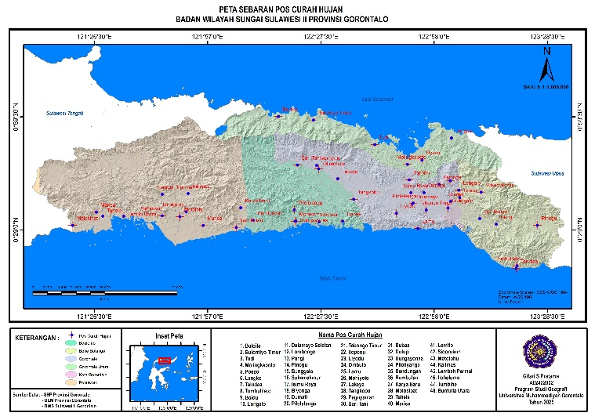
Figure 1. Rainfal distribution post

Data Management and Analysis
This study uses a quantitative descriptive research design with a spatial analysis approach. This design was chosen because the study aims to describe and classify climate patterns based on rainfall characteristics without manipulating the variables studied. The quantitative approach is used to process rainfall data in numerical form, while spatial analysis is applied to observe the spatial distribution of climate patterns in Gorontalo Province. The type of data used in this study is secondary data, in the form of monthly rainfall data for the last 10 years, 2015–2024. The data was obtained from official agencies, namely Badan Meteorologi, Klimatologi, dan Geofisika (BMKG) and the Badan Wilayah Sungai (BWS) of Sulawesi II, Gorontalo Province. The data comes from rainfall observation stations spread across the region.Gorontalo Province and is considered representative to describe regional climate conditions.

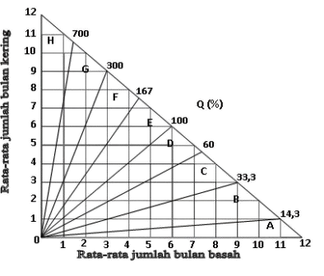
Figure 2. Schidt-Ferguson Curve Diagram (FH Schmidt and JHA Ferguson, 1951)

The initial stage of the research involved a data consistency test to ensure the reliability and homogeneity of the rainfall data used. The consistency test was conducted using the Double Mass Curve method, which compares the cumulative rainfall at the test station with that at the reference station (Ruspa et al., 2025; Adhikari et al., 2022). Data is declared consistent if the relationship graph shows a linear pattern without significant changes in slope, so it is suitable for use for further analysis (Yogafanny et al., 2022). After the data was declared consistent, a Schmidt–Ferguson climate classification analysis was performed.

Table 1. Schmidt-Ferguson Climate Type Categories (Ferguson & Padang, 2023)
Climate Type | Q value | Criteria
Type A | 0 < Q < 0.143 | Very Wet
Type B | 0.143 < Q < 0.333 | Wet
Type C | 0.333 < Q < 0.600 | A bit wet
Type D | 0.600 < Q < 1.000 | Currently
Type E | 1.000 < Q < 1.670 | A bit dry
Type F | 1.670 < Q < 3.000 | Dry
Type G | 3.000 < Q < 7.000 | Very Dry
Type H | 7.000 < Q | Extraordinarily Dry

This method classifies climates based on the Q index value, which is the ratio between the average number of dry months and the average number of wet months. Wet months are defined as months with more than 100 mm of rainfall, while dry months are those with less than 60 mm of rainfall. The resulting Q value is then used to determine climate type according to the Schmidt–Ferguson criteria (Sila et al., 2022).
The climate classification according to Schmidt-Ferguson is more suitable for use in the plantation sector, because it has advantages including being suitable for tropical areas, paying close attention to temperature fluctuations, simple data analysis and being suitable for the whole world (Rahmanto et al., 2022). Schmidt Ferguson determined BB, BL and BK year by year during the observation period which were then added up and the average calculated (Ruqoyah et al., 2023), can be formulated:

Average Dry Month

Md = $\frac{\sum{fd}}{T}$ (1)

Information: Md = average dry month; ∑fd = Frequency of dry months; T = the number of years of research.

Average Wet Month:

Mw = $\frac{\sum{fw}}{T}$ (2)

Information: Mw = average wet month; ∑fw = frequency of wet months; T = the number of years of research.

Q Value

Q = $\frac{Md}{Mw} x 100\%$ (3)

Where, Md = average dry month; Mw = average wet month; Q = Climate type SF. Q value to determine the type and nature of rain (Pratama et al., 2023).
Next, a spatial analysis of climate patterns was conducted using a Geographic Information System (GIS). The climate type values ​​for each rainfall station were mapped spatially using the Inverse Distance Weighting (IDW) interpolation method (Karimaha, 2026). The IDW method was chosen because it is able to describe spatial variations based on the proximity between observation points and is in accordance with the relatively even distribution of rainfall stations in the research area. The IDW method was adopted to estimate rainfall in areas that do not have observation stations, by utilizing reference stations (Susanto et al., 2024). Overall, this research design allows for structured analysis ranging from data quality verification, climate type grouping, to visualization of the spatial distribution of climate patterns.
This method will work well when the sample points are evenly (randomly) distributed throughout the area and are not clustered. The basis used in this spatial data processing process is the coordinates of the climatology station posts that already have Schmidt-Ferguson climate values ​​so that spatial data processing can be carried out using interpolation. The fundamental data used in this spatial processing process includes the geographic coordinates of the climatology station posts that have been integrated with the Schmidt-Ferguson climate index values, thus enabling the transformation of tabular data into precise spatial information for regional analysis needs.

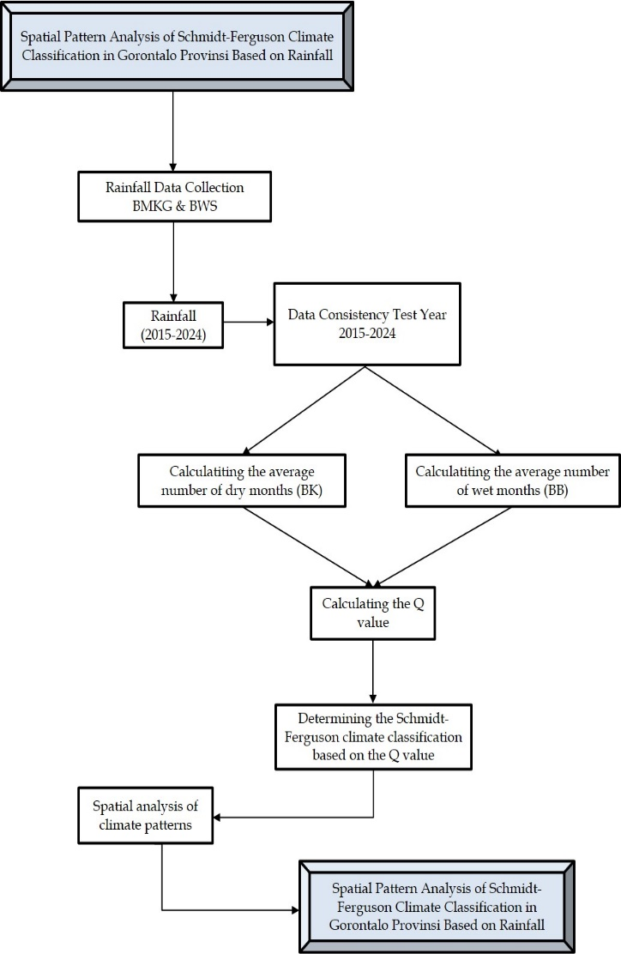
Figure 3. Stage flowchart

Result and Discussion

Results
Data Consistency Test
Testing the consistency or reliability of rainfall data using the Double Mass Curve method, shows that rainfall data at most stations is homogeneous and consistent (Ruspa et al., 2025). The relationship graph between the cumulative rainfall of the test station and the reference station forms a linear pattern without significant changes in slope. Thus, the rainfall data is deemed suitable for use in Schmidt–Ferguson climate classification analysis (Searcy & Hardison, 1960).
A consistency test of rainfall data in North Gorontalo Regency using the Double Mass Curve method revealed a very strong linear relationship. The graph formed a constant straight line up to an accumulation of 25,000 mm, indicating that the data was consistent and free from external interference, allowing for direct use without correction.

Figure 4. Consistency test of rainfall data in North Gorontalo Regency

These results confirm the findings (Subehi et al., 2016). This study examines the characteristics of precipitation in Gorontalo, highlighting the important role of local dynamics and watershed interactions on rainfall distribution patterns. Given these influences, data consistency testing is a vital step in ensuring the accuracy of hydrological analyses, such as flood discharge estimation. The absence of deviations in the dual mass curve (DMC) in this study confirms the reliability of the data used for water resource modeling in North Gorontalo.
Meanwhile, Research from Korres et al. (2021). This often highlights that DMC is subjective and highly dependent on the choice of reference station. If the reference station is also unstable, then the linearity results at the test station can be "pseudo" ormisleading.

Figure 5. Consistency test of rainfall data in Gorontalo Regency

The consistency test of the Double Mass Curve method in Gorontalo Regency demonstrated a very strong linear relationship between the test and reference stations. The graph formed a constant straight line up to accumulations above 18,000 mm, indicating that the data were homogeneous and free from non-climatic interference. Thus, the data were deemed reliable for further hydrological analyses such as water balance and flood control, while also confirming the spatial uniformity of rainfall patterns (Sriwongsitanon et al., 2023).
This research is in line with Korres et al. (2021), he used the Double Mass Curve to evaluate the homogeneity of rainfall data from several rainfall stations. The results showed that most of the data was homogeneous, and the DMC was used to adjust for inhomogeneity.
In contrast to the results of previous research, the use of the Double Mass Curve shows that some stations are not completely homogeneous, so this method needs to be combined with other statistical tests (Eris & Agiralioglu, 2012).

Figure 6. Consistency test of rainfall data in Bonebolango Regency

The Double Mass Curve test results in Bone Bolango Regency demonstrate high data reliability, with a consistent linear graph up to an accumulation of >28,000 mm. This demonstrates the data's homogeneity, freedom from non-climatic disturbances, and high validity for advanced hydrological analysis and water infrastructure planning in Gorontalo Province.
In research Yogafanny et al. (2022), Double Mass Curve is used to ensure the consistency and homogeneity of annual rainfall data, where the results show that the data is consistent and homogeneous because the cumulative graph follows a linear line.
However, several other studies from Hardison (1960) emphasizes that the Double Mass Curve is not always sufficient to detect all possible inhomogeneities in rainfall series without the support of additional statistical tests such as Mann-Kendall or other trend tests.
The Double Mass Curve consistency test in Boalemo Regency demonstrated high data reliability, with a stable linear graph up to >18,000 mm. This homogeneous pattern demonstrates the data's freedom from non-climatic disturbances and technical errors, making it highly valid for use without correction in strategic hydrological analysis and reflecting the harmony of rainfall patterns in Gorontalo Province.

Figure 7. Consistency test of rainfall data in Boalemo Regency

In line with Ruspa et al. (2025), this study found that the results of the Double Mass Curve test showed a linear relationship between the main station data and the comparison so that the rainfall data was assessed as consistent and homogeneous, in accordance with the straight-line characteristics on the DMC graph which showed data homogeneity.
However, Khalil (2021) shows that although the multiple mass curves may show linearity, some stations remain classified as 'doubtful' or 'suspect' after other formal statistical tests, so that DMC alone is not always sufficient to conclude data homogeneity absolutely.

Figure 8. Consistency test of rainfall data in Pohuwato Regency
The Double Mass Curve consistency test in Pohuwato Regency demonstrated high reliability with a homogeneous linear graph up to an accumulation of >13,000 mm. The data was proven free from non-climatic disturbances and technical errors, making it highly reliable for strategic hydrological analysis, irrigation planning, and disaster mitigation without the need for correction.
The use of the Double Mass Curve test as a data consistency evaluation tool is also applied by Yanos (2022), in this study, a linear double mass curve graph was used to ensure that station rainfall data was consistent and suitable for further analysis. This approach aligns with research findings in Gorontalo Province.
The graph above shows that rainfall data across the entire study area is consistent and homogeneous. By meeting these consistency requirements, the rainfall data is suitable for use in climate classification analysis and climate pattern mapping in Gorontalo Province (Ackom et al., 2020).

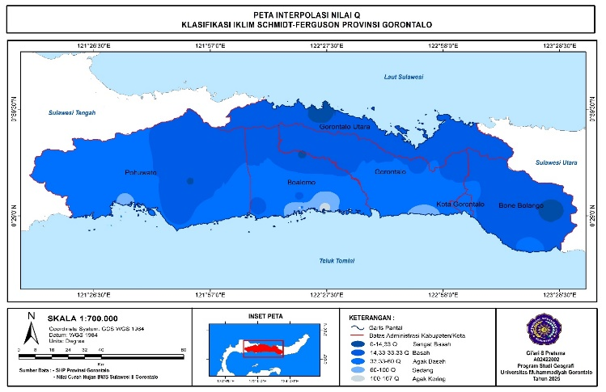
Figure 9. Rainfall map for 2015-2024 in Gorontalo Province

The spatial distribution of rainfall in Gorontalo Province for the period 2015–2024 shows a clear variation influenced by topographic and geographic factors. Based on the interpolation map, higher rainfall intensity is predominantly observed in the eastern and central parts of the province, particularly in Bone Bolango and parts of Pohuwato, which are characterized by mountainous and hilly terrain. These areas tend to receive more rainfall due to orographic effects, where moist air masses from surrounding seas are forced to rise and condense. In contrast, relatively lower rainfall is observed in coastal and lowland areas, especially in parts of Boalemo and western Pohuwato, indicating weaker orographic influence and greater exposure to dry air circulation. The overall pattern suggests that rainfall distribution in Gorontalo is not uniform but forms a gradient from wetter inland and highland areas to relatively drier coastal zones. This spatial variability has important implications for regional planning, particularly in determining agricultural suitability, water resource allocation, and identifying areas prone to hydrometeorological hazards such as floods in high rainfall zones and drought in low rainfall areas.

Schmidt-Ferguson Climate Type Q Value Classification in Gorontalo Province
The results table 2 of the Schmidt–Ferguson climate classification based on Q index values show that Gorontalo Province exhibits significant spatial variability in climate types, ranging from very wet (A) to slightly dry (E). This variation reflects differences in rainfall distribution influenced by topography, elevation, and proximity to moisture sources such as the sea.
In North Gorontalo Regency, climate types are dominated by wet (B) and very wet (A) categories, with Q values ranging from 7.6 to 27.5. The presence of very wet conditions, particularly at East Bulontiyo (Q = 7.6), indicates minimal dry months and consistently high rainfall throughout the year. This pattern suggests strong maritime influence and possible orographic effects that enhance precipitation.
In Gorontalo Regency, a wider variation of climate types is observed, ranging from wet (B), moderately wet (C), to moderate (D), with Q values between 17.7 and 93.6. Most stations fall into the moderately wet (C) category, indicating a more balanced distribution between wet and dry months. The occurrence of moderate climate (D), such as in Lamu (Q = 93.6), reflects longer dry periods, likely associated with lower elevation or reduced exposure to moist air masses.
Bone Bolango Regency is generally dominated by wet (B) and moderately wet (C) climates, with one station classified as very wet (A), namely Pinogu (Q = 9.1). This condition is strongly influenced by mountainous topography, which enhances rainfall through orographic processes. Areas with higher elevation tend to receive more consistent rainfall compared to surrounding regions.
Boalemo Regency shows the highest variability, with climate types ranging from very wet (A) to slightly dry (E). Notably, Modelomo (Q = 119) represents the driest condition (E), indicating a significant number of dry months. This contrast suggests that Boalemo is influenced by both coastal dryness and localized topographic effects, resulting in heterogeneous climate conditions.
In Pohuwato Regency, climate types range from very wet (A) to moderate (D), with most stations classified as wet (B) and moderately wet (C). The presence of moderate climate in North Lemito (Q = 67.3) indicates relatively longer dry periods, while very wet conditions in Kalimas (Q = 13.3) reflect high rainfall intensity. This variation highlights the transitional nature of the region between mountainous and coastal influences.

Table 2. Q Values ​​of Schmidt-Ferguson Climate Types in Gorontalo Province
CH Station Name | Q value | Climate Type
North Gorontalo Regency Rainfall Station
Buloila | 24.3 | (B)
East Bulontiyo | 7.6 | (A)
Study | 17.2 | (B)
Molingkopoto | 27.5 | (B)
Gorontalo Regency Rainfall Station
South Dulamayo | 17.7 | (B)
Bungalow | 53.6 | (C)
Your Great Content | 38.7 | (C)
Biyonga | 29.3 | (B)
Dulamayo | 54.2 | (C)
Pilolalenga | 50.8 | (C)
East Tabong | 40.3 | (C)
Iloponu | 27.4 | (B)
Lamu | 93.6 | (D)
Mohiolo | 20.7 | (D)
Lakeya | 25 | (B)
Olimohulo | 20.73 | (B)
Bone Bolango Regency Rainfall Station
Taludaa | 23.7 | (B)
Tombulilato | 45.7 | (C)
Boidu | 51.7 | (C)
Longalo | 18.8 | (B)
Lombongo | 21.4 | (B)
Pangi | 17.4 | (B)
Pinogu | 9.1 | (A)
Boalemo Regency Rainfall Station
Sari Tani | 12.5 | (A)
Tangkobu | 55.4 | (C)
Buba | 44.8 | (C)
Dulupi | 113.6 | (C)
Hungayonaa | 36.6 | (C)
Modelomo | 119 | (E)
Piloliyanga | 23.5 | (E)
Bendungan | 25.6 | (E)
Pohuwato Regency Rainfall Station
Bumbulan | 25.3 | (B)
Motolohu | 28.8 | (B)
Iloheluma | 20.7 | (B)
Kalimas | 13.3 | (A)
North Lemito | 67.3 | (D)
Tahele | 41.7 | (C)
Marisa | 42.5 | (C)
Molosipat | 52.5 | (C)

Overall, the spatial distribution of climate types in Gorontalo Province demonstrates a clear pattern: wetter climates (A–B) are generally found in mountainous and interior regions, while drier climates (C–E) are more common in coastal and lowland areas. These findings confirm that topography and geographic location play a crucial role in controlling rainfall distribution. The results are consistent with previous studies indicating that orographic effects and proximity to moisture sources significantly influence regional climate patterns (Faraslis et al., 2023; Ackom et al., 2020).
From a practical perspective, this variability has important implications for regional planning. Areas with very wet and wet climates are more suitable for water-intensive agriculture but are also more prone to flooding and landslides (Koem & Rusiyah, 2018). In contrast, moderately wet to slightly dry areas require improved water management strategies, such as irrigation development and drought mitigation measures. Therefore, understanding spatial climate variation is essential for sustainable resource management and disaster risk reduction in Gorontalo Province.

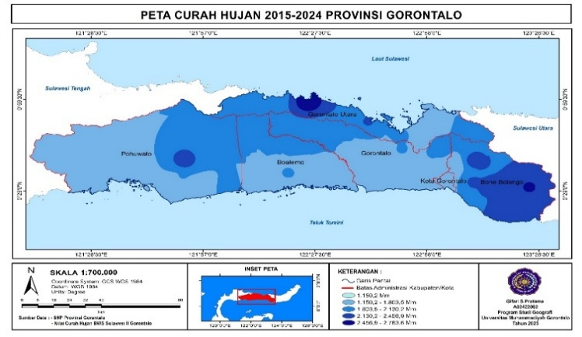
Figure 10. Schmidt-Ferguson climate Q value interpolation map in Gorontalo Province

Schmidt–Ferguson Q-index analysis reveals climate variation in Gorontalo, dominated by wet (B) and moderately wet (C) types, particularly in North Gorontalo, Bone Bolango, and Pohuwato. Boalemo Regency exhibits the most uneven rainfall distribution, with a range of types A (very wet) to E (moderately dry). This diversity confirms that local topographic and geographic factors significantly influence the climate characteristics of each region.
This study uses the Schmidt-Ferguson index to classify climate zones in Gorontalo Regency using monthly rainfall data. It found several climate types (B, C, D, E, and F) in the 1981–2020 period, and demonstrated changes in the extent of climate zones over time. This demonstrates that the Schmidt-Ferguson method effectively demonstrates variations in climate types within a region and that spatial factors (such as topography and rainfall distribution) influence the climate zoning results, in line with my statement (Moontuno et al., 2023).
Conclusion

This study successfully mapped climate variability in Gorontalo Province using the Schmidt–Ferguson classification, which showed a range of $Q$ indices between 7.6% and 119%, spanning the Very Wet (A) to Somewhat Dry (E) categories. These findings consistently achieved the research objectives by proving that mountainous areas such as Bone Bolango are dominated by a wet climate, while coastal areas tend to be drier, which implies the need for specific policies such as upstream zones to prevent flooding and the construction of reservoirs and the use of drought-resistant varieties in coastal zones. Although limited by the uneven distribution of rainfall stations and the 10-year data period that is prone to weather anomalies, this study provides crucial contributions to climate-based regional planning; In the future, the integration of CHIRPS satellite data and advanced spatial modeling such as Geographically Weighted Regression is highly recommended to improve mapping accuracy.

Acknowledgments
The authors would like to express their deepest gratitude to Universitas Muhammadiyah Gorontalo for the continuous support, facilities, and academic guidance provided throughout the completion of this research.

Author Contribution
Conceptualization, G.S.P., A.S.R.S., and T.D; methodology, D.O.S.; software, data analyzer and visualization G.S.P.; writing—review and editing, G.S.P., A.S.R.S.; supervision, A.S.R.S., and T.D.

Funding
Funding This research did not receive any external funding.

Conflict of Interest
The authors declare no conflict of interest.

References

Ackom, E. K., Adjei, K. A., & Odai, S. N. (2020). Spatio-temporal rainfall trend and homogeneity analysis in flood prone area: case study of Odaw river basin-Ghana. SN Applied Sciences, 2(12), 1–26. https://doi.org/10.1007/s42452-020-03924-3
Adhikari, K., Chhetri, K., Basnet, E., Chozom, K., Sharma, K., Giri, A., Bumpa, L., & Sharma, V. (2022). Identification of Inconsistencies in Historic Rainfall Records of the Himalayas of Bhutan. Journal of Water Engineering and Management, 3(2), 31–45. https://doi.org/10.47884/jweam.v3i2pp31-45
Ariska, M., Suhadi, Supari, Irfan, M., & Iskandar, I. (2024). Detection of Dominant Rainfall Patterns in Indonesian Regions Using Empirical Orthogonal Function (EOF) and Its Relation with ENSO and IOD Events. Science and Technology Indonesia, 9(4), 1009–1023. https://doi.org/10.26554/sti.2024.9.4.1009-1023
Chakraborty, S., Pan, S., Pal, S. C., Islam, A. R. M. T., Alam, E., & Islam, M. K. (2025). Evaluating the impact of rainfall patterns on sustainable agricultural crop production. Discover Sustainability, 6(1). https://doi.org/10.1007/s43621-025-01392-6
Eris, E., & Agiralioglu, N. (2012). Homogeneity and Trend Analysis of Hydrometeorological Data of the Eastern Black Sea Region , Turkey. Journal of Water Resource and Protection, 2012(February), 99–105. https://doi.org/10.4236/jwarp.2012.42012
Faraslis, I., Dalezios, N. R., Alpanakis, N., Tziatzios, G. A., Spiliotopoulos, M., Sakellariou, S., Sidiropoulos, P., Dercas, N., Domínguez, A., Martínez-López, J. A., López-Urrea, R., Karam, F., Amami, H., & Nciri, R. (2023). Remotely Sensed Agroclimatic Classification and Zoning in Water-Limited Mediterranean Areas towards Sustainable Agriculture. Remote Sensing, 15(24). https://doi.org/10.3390/rs15245720
Ferguson, & Padang, K. (2023). Analisis Klasifikasi Tipe Iklim Dari Data Curah Hujan Menggunakan Metode Schmidt-Ferguson Di Kabupaten Padang Pariaman. Jurnal Teori dan Aplikasi Fisika, 29-38. https://doi.org/10.59841/saber.v3i1.2205
Gradiyanto, F., Parmantoro, P. N., & Suharyanto. (2025). Impact of climate change on Kupang River flow and hydrological extremes in Greater Pekalongan, Indonesia. Water Science and Engineering, 18(1), 69–77. https://doi.org/10.1016/j.wse.2024.03.005
Hanifa, R., & Wiratmo, J. (2024). ENSO and IOD Influence on Extreme Rainfall in Indonesia: Historical and Future Analysis. Agromet, 38(2), 78–87. https://doi.org/10.29244/j.agromet.38.2.78-87
Hidayat, A. S. A., Baskoro, W. T., Unsuriyah, Z., Yuliara, I. M., Widagda, I. G. A., Pramarta, I. B. A., & Kurnia, W. G. (2023). Analisis Spasial Penentuan Tipe Iklim Menurut Klasifikasi Schmidt-Ferguson Menggunakan Metode Thiessen-Polygon Di Kabupaten Bojonegoro Berdasarkan Data Curah Hujan Tahun 2016–2022. Kappa Journal, 7(3), 488–492. https://doi.org/10.29408/kpj.v7i3.23128
Indrawan, Dangkua, T., & Jaya, R. (2025). Comparative Morphometric Analysis for Flood Risk Assessment in Alo and Molamahu Sub-Watersheds, Gorontalo Regency. Jurnal Penelitian Pendidikan IPA, 11(8), 535–545. https://doi.org/10.29303/jppipa.v11i8.11924
Khalil, A. (2021). Inhomogeneity detection in the rainfall series for the Mae Klong River Basin , Thailand. Applied Water Science, 11(9), 1–11. https://doi.org/10.1007/s13201-021-01474-6
Koem, S., & Rusiyah, R. (2018). Spatiotemporal Characteristics of Meteorological Drought in Gorontalo Regency in 1981- 2016. Jurnal Pengelolaan Sumberdaya Alam Dan Lingkungan (Journal of Natural Resources and Environmental Management), 8(3), 355–364. https://doi.org/10.29244/jpsl.8.3.355-364
Korres, W., Reichenau, T. G., Fiener, P., Koyama, C. N., Bogena, H. R., Cornelissen, T., Baatz, R., Herbst, M., Diekkrüger, B., Vereecken, H., & Schneider, K. (2021). Spatio-temporal soil moisture patterns – A meta-analysis using plot to catchment scale data. Journal of Hydrology, 520, 326–341. https://doi.org/10.1016/j.jhydrol.2014.11.042
Leonard, F., Hasanuddin, Wahyuni, & Prattyni, V. P. (2024). Analisis Curah Hujan dan Klasifikasi Tipe Iklim Menggunakan Metode Schmidt-Ferguson (Studi Kasus: Danau Tempe). Jurnal Media Teknik Sipil, 2(2), 12–21. https://doi.org/10.56963/judiateks.v2i2.441
Maulana, K. M., Dangkua, T., Jaya, R., & Mulabbi, A. (2025). Morphometric Characteristics and Their Relation to Flood Events in Paguyaman Watershed, Gorontalo. Jurnal Penelitian Pendidikan IPA, 11(8), 476–488. https://doi.org/10.29303/jppipa.v11i8.11909
Moontuno, V., Maryati, S., & Koem, S. (2023). Deteksi Perubahan Zona Agroklimat Schmidt-Ferguson. Jurnal Kajian, Penelitian Dan Pengembangan Pendidikan, 11(2), 191–200. https://doi.org/10.31764/geography.v11i2.15821.
Moontuno, V. V., Maryati, S., & Koem, S. (2023). Deteksi Perubahan Zona Agroklimat Schmidt-Ferguson Menggunakan Sistem Informasi Geografis Di Kabupaten Gorontalo. Geography : Jurnal Kajian, Penelitian Dan Pengembangan Pendidikan, 11(2), 191. https://doi.org/10.31764/geography.v11i2.15821
Mulsandi, A., Koesmaryono, Y., Hidayat, R., Faqih, A., & Sopaheluwakan, A. (2024). On The Interannual Variability of Indonesian Monsoon Rainfall (IMR): A Literature Review of The Role of its External Forcing. Jurnal Meteorologi Dan Geofisika, 24(2), 115–127. https://doi.org/10.31172/jmg.v24i2.1049
Olii, M. R., Olii, A., & Pakaya, R. (2021). Analysis of Spatial Distribution of the Drought Hazard Index (DHI) by Integration AHP-GIS-Remote Sensing in Gorontalo Regency. Journal of the Civil Engineering Forum, 8(January), 81–96. https://doi.org/10.22146/jcef.3595
Otto, F. E., Zachariah, M., Saeed, F., Siddiqi, A., Kamil, S., Mushtaq, H., ... & Clarke, B. (2023). Climate change increased extreme monsoon rainfall, flooding highly vulnerable communities in Pakistan. Environmental Research: Climate, 2(2). https://doi.org/10.1088/2752-5295/acbfd5
Pratama, G. S., & Sardiana, I. K. (2023). Pemetaan Klasifikasi Iklim Schmidt-Ferguson dan Kesesuaian Agroklimat Tanaman Cabai Merah (Capsicum annuum) di Provinsi Bali. Agrotrop : Journal on Agriculture Science, 13(2), 170. https://doi.org/10.24843/ajoas.2023.v13.i02.p02
Putranto, W. W., Nuarsa, I. W., Kartini, N. L., Andi Yuda, I. W., & Wiratmaja, I. M. D. (2022). Pemetaan Zona Agroklimat Schmidt Ferguson Menggunakan Data Stasiun Pengamat Hujan Dan Produk Data Satelit Imerg Di Provinsi Bali. ECOTROPHIC : Jurnal Ilmu Lingkungan (Journal of Environmental Science), 16(2), 244. https://doi.org/10.24843/ejes.2022.v16.i02.p11
Rahmanto, E., Rahmabudhi, S., & Kustia, T. (2022). Kajian analisis spasial penentuan tipe iklim menurut klasifikasi Schmidt–Ferguson menggunakan metode Thiessen–Polygon di Provinsi Riau. Buletin GAW Bariri, 3(1), 35-42. https://doi.org/10.31172/bgb.v3i1.66
Ren, Z., Zhao, H., Shi, K., & Yang, G. (2023). Spatial and Temporal Variations of the Precipitation Structure in Jiangsu Province from 1960 to 2020 and Its Potential Climate-Driving Factors. Water (Switzerland), 15(23). https://doi.org/10.3390/w15234032
Karimah, R. Z., Azzahmi, Z. Z., Prasetya, A. D., Apsari, A. N. D., Fatah, F., & Azziz, K. N. (2024). Pemodelan spasial prediksi curah hujan melalui metode inverse distance weighting di wilayah Sumatera Barat tahun 2026. Geomedia Majalah Ilmiah dan Informasi Kegeografian, 22(1). https://doi.org/10.21831/gm.v22i1.68239
Ruqoyah, R., Ruhiat, Y., & Saefullah, A. (2023). Analisis Klasifikasi Tipe Iklim Dari Data Curah Hujan Menggunakan Metode Schmidt-Ferguson (Studi Kasus: Kabupaten Tangerang). Jurnal Teori Dan Aplikasi Fisika, 11(01), 29–38. https://doi.org/10.23960/jtaf.v11i1.3076
Ruspa, R., Permana, S., & Hantari, A. N. (2025). Analisis Konsistensi Data Curah Hujan Terhadap Debit Andalan: Studi Kasus: Bendung Leuwipeundeuy. Jurnal Konstruksi, 23(1), 273-282. https://doi.org/10.33364/konstruksi/v.23-1.1881
Searcy, J. K., & Hardison, C. H. (1960). Double-Mass Curves. WaterSupply Paper 1541B, 66. https://doi.org/10.3133/wsp1541B
Sila, K., Mukti, T., Dwi, B., Nugroho, A., & Maftukhah, R. (2022). Classification of Climate and Land Suitability of Rice in East Sumba Regency, East Nusa Tenggara. In 2nd International Conference on Smart and Innovative Agriculture (ICoSIA 2021) (pp. 122-129). Atlantis Press. https://doi.org/10.2991/absr.k.220305.018
Sriwongsitanon, N., Kaprom, C., Tantisuvanichkul, K., Prasertthonggorn, N., Suiadee, W., Bastiaanssen, W. G., & Williams, J. A. (2023). The combined power of double mass curves and bias correction for the maximisation of the accuracy of an ensemble satellite-based precipitation estimate product. Hydrology, 10(7), 154. https://doi.org/10.3390/hydrology10070154
Subehi, L., Wibowo, H., & Jung, K. (2016). Characteristics of Rainfall-Discharge and Water Quality at Limboto Lake , Gorontalo , Indonesia. 48(3), 288–300. https://doi.org/10.5614/j.eng.technol.sci.2016.48.3.4
Suhadi, S., Mabruroh, F., Wiyanto, A., & Ikra, I. (2023). Analisis Fenomena Perubahan Iklim Terhadap Curah Hujan Ekstrim. OPTIKA: Jurnal Pendidikan Fisika, 7(1), 94–100. https://doi.org/10.37478/optika.v7i1.2738
Susanto, S., Pratikto, H., Winarto, S., & Siswanto, E. (2024). Pemetaan Curah Hujan dengan Metode Interpolasi Invers Distance Weighting (IDW) Kabupaten Kediri. Jurnal Engineering, 15(1), 44-55. https://doi.org/10.24905/jureng.v15i1.7
Tiwari, H., Rai, S. P., Kumar, D., & Sharma, N. (2016). Rainfall erosivity factor for India using modified fourier index. Journal of Applied Water Engineering and Research, 4(2), 83–91. https://doi.org/10.1080/23249676.2015.1064038
Vijith, H. (2020). Papers in Applied Geography Statistical Trend Characteristics of Rainfall in the Baram River Basin (Malaysian Borneo) Statistical Trend Characteristics of Rainfall in the Baram River Basin (Malaysian Borneo). Papers in Applied Geography, 1–30. https://doi.org/10.1080/23754931.2020.1847728
Wang, B., Biasutti, M., Byrne, M. P., Castro, C., Chang, C. P., Cook, K., ... & Zhou, T. (2021). Monsoons climate change assessment. Bulletin of the American Meteorological Society, 102(1), E1–E19. https://doi.org/10.1175/BAMS-D-19-0335.1
Yamamoto, K., Sayama, T., & Apip. (2021). Impact of climate change on flood inundation in a tropical river basin in Indonesia. Progress in Earth and Planetary Science, 8(1). https://doi.org/10.1186/s40645-020-00386-4
Yanos, M. H. (2022). Analysis of Rainfall Variability in the Province of Quirino. Journal of Environmental Science and Economics, 1(2), 44–50. https://doi.org/10.56556/jescae.v1i2.20
Yasa, I. W., Sulistiyono, H., Saadi, Y., & Hartana. (2022). Spatial Climate Forecasting for Climatology Disaster Mitigation. Environment and Ecology Research, 10(6), 786–796. https://doi.org/10.13189/eer.2022.100613
Yogafanny, E., & Legono, D. (2022). A comparative study of missing rainfall data analysis using the methods of inversed square distance and arithmetic mean. ASEAN Engineering Journal, 12(2), 69-74. https://doi.org/10.11113/aej.V12.16974
Yogafanny, E., & Legono, D. J. (2022). a Comparative Study of Missing Rainfall Data Analysis Using the Methods of Inversed Square Distance and Arithmetic Mean. ASEAN Engineering Journal, 12(2), 69–74. https://doi.org/10.11113/aej.V12.16974

