The Use of Practical Video Demonstration for Class VII Photosynthetic Materials to Stimulate Basic Science Process Skills
Donny Auliya Arrohman¹*, Normalia Sandy Palumpun¹, Jumadi², Zuhdan Kun Prasetyo²

¹Science Education Program on Graduate School, Faculty of Mathematics and Natural Sciences, Yogyakarta State University, Indonesia
²Department of Science Education, Faculty of Mathematics and Natural Sciences, Yogyakarta State University, Indonesia

DOI: 10.29303/jppipa.v7i4.813

Article Info  Received: June 22th, 2021  Revised: September 10th, 2021  Accepted: October 11th, 2021 |  | Abstract: Science process skills are one of the most important skills to be mastered by every student. These skills will teach and train students to conduct an investigation or scientific discovery. Science process skills consist of two main groups, namely basic and integrated science process skills. The research carried out here focuses on basic science process skills. This research aims to see how photosynthetic material practicum demonstration videos for class VII stimulate. The type of research used in this study is descriptive analysis, with the sample used as many as 17 students spread out in one class, namely class VIIF. The data collected consists of qualitative data and quantitative data. Qualitative data was obtained when researchers conducted interviews and observations of students, while quantitative data was obtained through the results of pretest and posttest basic science process skills. The results showed that overall, students experienced an increase in the percentage of achievement of each aspect of basic science process skills (observing from 67.65 to 85.29%, classifying from 85.29 to 94.12%, measuring from 78.43 to 88.24%, inference from 52.94 to 70.59%, predicting from 76.57 to 88.24%, and communicating from 82.35 to 94.12%). Other results obtained in this study are several obstacles when the online learning process is carried out, namely the instability of the internet network, insufficient time to conduct video conferencing, and some who experience slow video running.
 |  | Keywords: Video demonstration of practicum; photosynthesis; basic science process skills
Citation: | Arrohman, D., Palumpun, N., Jumadi, J., & Prasetyo, Z. (2021). The Use of Practical Video Demonstration for Class VII Photosynthetic Materials to Stimulate Basic Science Process Skills. Jurnal Penelitian Pendidikan IPA, 7(4), 693-700. doi:https://doi.org/10.29303/jppipa.v7i4.813

Introduction

Natural Sciences is one of the sciences that consists of several branches, including physics, chemistry, and biology. The concepts and theories contained in science are obtained from an experiment conducted by scientists based on a scientific procedure (Susilawati et al., 2021). Science itself does not only discuss concepts, but there are four main aspects that build scientific knowledge, including science, the investigative nature of science, science as a way of thinking, and the interaction of science, technology, and society (Rusilowati 2018). The function of science itself in the world of education is expected to develop the abilities and potentials contained in students in terms of cognitive, psychomotor, and affective (Hasasiyah et al., 2020).
One very inherent skill needs to be mastered by students in the learning process at school, which will later train these students to do everything based on scientific procedures. These skills are science process skills. Science process skills in science learning need to be improved. This is because when students are accustomed to using these skills in daily life, it will be easy for them to face a scientific problem that will be solved by a scientific process (Herda et al., 2020). Not only that, science process skills will make the learning process livelier and more interesting. In the implementation, the process will provide opportunities for students to be directly involved in the material they are learning (Maharani et al., 2020). Yumuşak (2016) added that apart from making science learning livelier and students becoming more active, science process skills themselves will invite students to be more responsible for what they know and process the information they receive.
Science process skills are generally divided into two groups, namely basic science process skills and integrated science process skills. Darmaji et al. (2019) mention that basic science process skills consist of observing, concluding, measuring, communicating, classifying, and predicting, while integrated science process skills include controlling variables, defining variables, making hypotheses, planning an experiment, processing and interpreting experimental data. Aliyah & Erman (2021) classify basic science process skills as consisting of 7 elements: observing, classifying, measuring, and using numbers, making conclusions, predicting, communicating, and using space and time. For integrated process skills, there are five elements name: interpreting data, defining operational variables, controlling variables, making hypotheses, and experimenting
Tanti et al. (2020) mention that basic science process skills have elements including observation, classifying, measuring, predicting, communicating, and concluding. Meanwhile, integrated process skills consist of identifying variables, making graphs, obtaining and processing data, explaining relationships between variables, making hypotheses, analyzing experiments, planning an experiment, and conducting experiments.
In Indonesia, several studies related to science process skills have been carried out, one of which was carried out by Lestari & Handayani (2021). The results showed that among alumni of students at private high schools in Bandung who continued their studies in college were 69% of students who found it difficult to perform practical procedures, 43% found it difficult to follow a biologic practicum, and 59% found it difficult to use practicum tools. Then Siswanto et al. (2016) themselves have measured science process skills and learning independence in two junior high schools in Grobogan district where the subject is class VIII as many as 60 students. 70%, interpreting graphics 20%, predicting 71%, applying concepts by 63%, and communicating 40%.
Of all the indicators, there are indicators that are still in the low category, namely observing, proposing hypotheses, planning, interpreting charts, and communicating in the low category. A few years later, Antrakusuma et al. (2017) conducted a study in Boyolali with the samples used were class XI students at SMAN 1 Teras. The observed indicators were 33.3% proficiency percentages, 19.05% predictions, classification 11.90%, applying 11.90%, planning experiments 9.52%, manipulating materials and equipment 7.14%, drawing conclusions 4.76%, and communicating get a percentage of 2.38%. So, it can be concluded that the science process skills in the school are in a low category. In the city of Surakarta in the 2015/2016 academic year, Ratnasari et al. (2018) measurements have been carried out with the measurement focus on class X physics subjects. The results are known that to formulate a hypothesis (2.88%), design experiments (2.10%), interpreting data (5.10%), applying concepts (70.20%), communicating (6.64%), and writing conclusions (13.08%).
Research conducted by Sunyono (2018) in Lampung province measured science process skills in grade IX. The result was that science process skills were still in the low category. In the 2019/2020 academic year, Herda et al. (2020) conducted research in Jambi with a focus on science process skills in Chemistry subjects. The results were the same as some previous studies, namely science process skills there were still in the low category.
The low science process skills in several cities in Indonesia are at least caused by several factors, including the low science process skills of educators, lack of teaching materials that develop and improve science process skills, lack of measurement practices during learning activities, lack of science teachers to teach science process skills, still focus on mastering scientific concepts only, and the system of teaching and learning activities carried out is still traditional (lectures and teacher center), so that students do not explore science process skills (Herda et al., 2020; Sunyono 2018).
Based on the research results of science process skills and the factors that cause low science process skills, one solution can be given to training students to develop science process skills, namely through the use of digital technology in the form of video. If we look at the current situation in 2021, precisely in April, several schools are still implementing online learning processes due to the Covid-19 pandemic. So, we need a learning innovation that does not only learn through conferences or assignments but also requires students to be equipped with special skills. The use of social media and learning videos can positively impact students to practice their skills, especially in terms of science process skills.
Through learning videos, there are several benefits that students can receive, including being able to stimulate students’ knowledge, train them to think logically, analytically, creatively, effectively, sharpen imagination power, and give a sense of fun to students, not only that through the use of learning videos. Students will be invited to discuss more what is contained in the video to transfer and exchange information between students and students and students and teachers (Hardianti and Asri 2017). The implementation of the use of learning videos in improving the Minimum Completeness Criteria for students has been carried out by researchers Yuniarti et al. (2015) on heat energy and heat transfer materials. The cycle learning system was carried out twice.
In the first cycle, after the implementation of the learning video, it was found that 73% achieved completeness, and for the second cycle, it reached 100% completeness. So that overall, students complete the material in the second cycle. The average learning outcomes for cycle 1 were 62, while in cycle two, the average was 76. Erniwati et al. (2014) have conducted research related to the use of video-based practicum media on temperature material and its changes in class VII obtained good quality learning and improving learning outcomes are shown in the experimental class, which has an average gain score of 0.40 compared to the control class which gets an average gain score of 0.24.
Studies related to photosynthesis are contained in the material for class VII SMP in semester 1, namely in the Energy material. The basic competencies that students in energy materials must meet are identifying the concept of energy, various energy sources, and changes in the form of energy in everyday life, including photosynthesis, and presenting experimental results on changes in energy forms, including photosynthesis (Permendikbud No. 37 of 2018). Simply put, photosynthesis is a process carried out by plants that process energy from the sun, carbon dioxide, and water to produce food, one of which is oxygen (Walker 2011). from the Netherlands, namely Jan Ingen Housz (Housz et al., 2005). The main plant in the Ingen Housz experiment was the water plant Hydrilla verticillata. When the plant was placed in the sun for a while, small bubbles appeared. These bubbles turn out to be a gas called oxygen (Maleh 2020).
Based on the background and literature review above, in this study, the problem is how to use photosynthetic demonstration videos to stimulate science process skills? And how do students respond to the use of photosynthetic demonstration videos shown through online learning? This study aimed to find out the use of photosynthetic demonstration videos in stimulating science process skills and to find out the responses of students regarding photosynthetic demonstration videos during online learning.

Method

The research method used is descriptive analysis. The place that was used as the research was SMP YPPK St. Don Bosco, Sorong, West Papua class VII F academic year 2020/2021, and this research was conducted on April 20, 2021. The sampling technique used was purposive sampling. Purposive sampling is one of the samplings through certain considerations (Sugiyono 2015). The considerations given here come from the science teacher.
These considerations are the atmosphere of Indonesia which is still a pandemic. It requires learning to be done online and reviewing the characteristics of students who come from various uniform academic abilities. It was decided that the sample class was class VII E. learners. There are two types of data obtained in this study, namely quantitative data and qualitative data. The qualitative data in the form of interviews conducted by researchers on five students who have varying levels of academic mastery, namely low, medium, and high and observational data during the learning process. While the quantitative data obtained came from the data from the pretest and posttest test results of basic science process skills.

Result and Discussion

The media used to facilitate students with researchers when online learning is carried out is using video conferencing. The type of video conferencing application used here is zoom meeting which is free. Zoom is used here because students are used to using the application. Zoom, which is free, is only able to facilitate video conferencing with a maximum duration of 40 minutes.
Before showing a demonstration video of the photosynthesis practicum, students are given a pretest of basic science process skills on photosynthetic material. Aspects in basic science process skills that are used as indicators in questions include observing, classifying, measuring, inference, predicting, and communicating (Aliyah & Erman 2021; Darmaji et al., 2019; Tanti et al., 2020). After doing the pretest. Furthermore, the students were given treatment related to the photosynthetic demonstration video-based learning delivered by the researcher.
In learning activities here, students are not only invited to see the video that is shown but students are invited to discuss and examine all the contents contained in the video that has been shown so that students will be trained and tested their ability to analyze both the concept of photosynthesis, measuring tools used and the results of video observation of photosynthesis practicum. Before ending the learning process, students were asked to work on the posttest questions of science process skills. The results of the percentage values of basic science process skills for pretest and posttest can be seen in table 1.

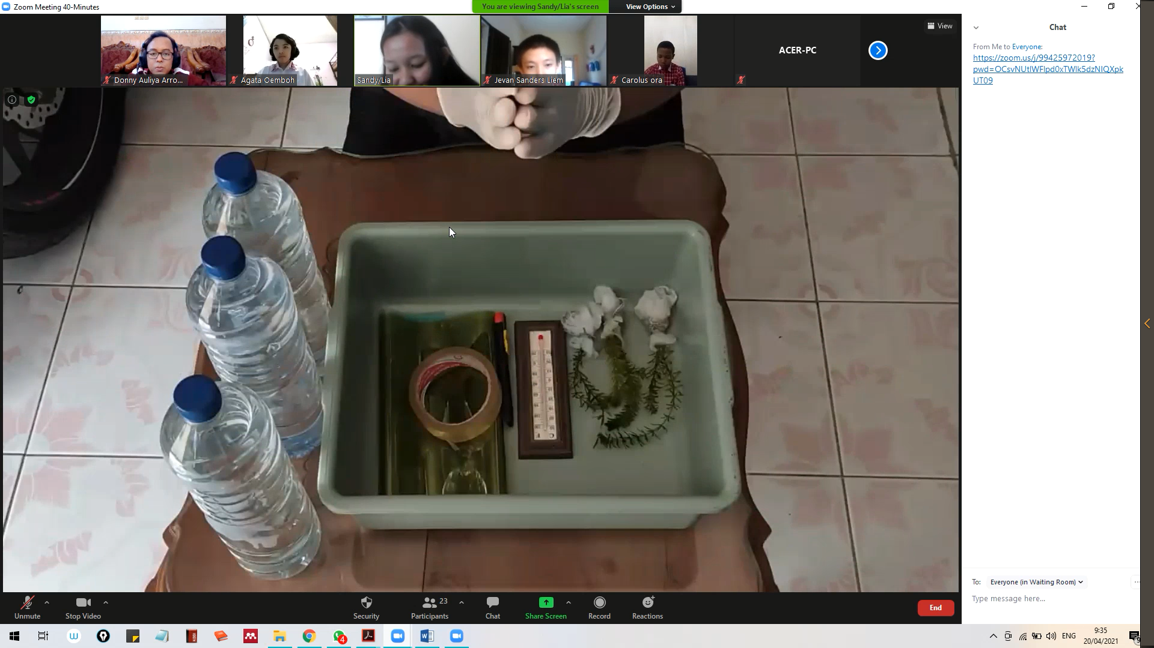
Figure 1. The process of displaying tools and materials in a demonstration video

Table 1. Percentage of achievement of pretest and posttest science process skills.
No | Aspect | Percentage of Achievement (%)
No | Aspect | Pretest | Posttest
1 | Observe | 67.65 | 85.29
2 | Classify | 85.29 | 94.12
3 | Measure | 78.43 | 88.24
4 | Inference | 52.94 | 70.59
5 | Predict | 76.47 | 88.24
6 | Communicating | 82.35 | 94.12

Based on table 1, it is known that there are two aspects that have a percentage value of achievement below 70%, namely aspects of observing and inference. These two aspects are the main task for researchers to improve and stimulate aspects of basic science process skills to increase the percentage value of achievement. After being given treatment learning using photosynthetic practicum demonstration videos, observing and inference aspects increased. And overall, there is an increase in the percentage of each indicator aspect of science process skills, meaning that through a learning demonstration video display system, students can improve basic science process skills. These results are in line with research that has been done by Nugroho (2015), which states that there is an increase between the results of the pretest and posttest for students’ science process skills when using photosynthetic practicum demonstration videos. This is because when students are given learning videos, they will carry out learning activities. Not only will the teacher listen to what is conveyed, but also they will carry out activities such as observing, demonstrating, and demonstrating.
In addition, through learning videos, students will train their motor skills and their abilities in carrying out their activities. This is in accordance with the results of research conducted by Hendraningrati & Fauziah (2022), which proves that the use of digital learning media is able to stimulate children’s fine motor skills because when given a video containing certain activities, the child will listen and then practice the activities contained in the video. In addition, the results of the study also show that there is a positive attitude contained in the child, which is more enthusiastic in carrying out the learning process.
Although there was an increase in students’ basic science process skills, in this study, there were a few things that were noted when photosynthetic practicum videos were displayed. When viewing videos through the zoom app, some students noticed the movement of the video experiencing problems, namely the lack of smooth changes in every view of the frame in the video. To solve this problem the video displayed by the researcher was sent through a shared WhatsApp group. Students are given time to observe, analyze, and collect whatever data is needed in the video. Another obstacle that can be identified is during the online learning process is the length of time provided by Zoom.
Zoom itself provides a free meeting time of 40 minutes. The time for 40 minutes to carry out the learning process, as well as this research, is very less, so a management system and a gradual link change are needed so that the learning process that takes place can run smoothly so that the researchers made two meetings (two times the link zoom change). The next obstacle to note is network instability. Students experience this event. Indications of this network instability are seen that some students experience the process of going in and out of zoom in the initial 5-10 minutes. Although there is network instability, overall, students can follow the learning process, which is carried out in an orderly manner after 5-10 minutes.
Cases of problems with zoom due to the inability to enter or view videos in zoom are caused by the instability of the interrupted internet connection. This is in line with research conducted by Kelana et al. (2021). The study results stated that the obstacles found in learning science through the Zoom meeting application were the lack of a good internet connection, wasteful use of the internet, and the lecturers themselves not being able to control fully observe students one by one.
Another study conducted by Haqien & Rahman (2020) shows that the use of zoom alone for online learning cases is less effective in terms of poor internet signal. This lack of effectiveness was identified because not all learners use Wi-Fi in online learning and strange disturbances such as annoying noises while doing the voice. Muliadi et al. (2021) added that during the online learning process one aspect that needs to be considered is the readiness of students, educators, and the learning environment must be really supportive. The learning environment here is like the smooth running of the internet. If the internet speed used by students experiences problems or disturbances, the learning process cannot run optimally.
Research on the use of photosynthetic practicum demonstration videos that have been carried out then obtains qualitative data through interviews conducted by researchers to selected students with varying academic abilities (low, medium, and high). Regarding the video dancing displayed by the interview results, the students as a whole answered that the video caught their attention because the video was able to prove the existence of photosynthesis in the form of oxygen which was shown through bubbles that emerged from the Hydrilla plant.
Furthermore, related to the sound quality in the video, the overall results of interviews with students answered that the quality of the sound produced could be heard clearly, and the language used in conveying information was easy to understand. Regarding the visual quality contained in the video, some students mentioned that the video quality was good and smooth, but there were also those who gave responses, sometimes the images were intermittent, and objects in the form of bubbles appeared in the video, sometimes it was difficult to observe. The problem has been analyzed, and it turns out that one of the causes resulting from the video breaking is the internet signal.
Photosynthetic practicum demonstration video, featuring two measuring instruments, namely a stopwatch and a thermometer, both measuring instruments play a role in measuring objects that occur in the video event. Based on the results of interviews and discussions carried out, the thermometer and stopwatch shown in the video can be seen clearly, and the measurement results are easy to read. Through the results of this interview, it is known that from the questions posed. It turns out that the value of measuring and observing students’ skills has increased.
Haryadi & Pujiastuti (2020) stated that learning that utilizes a video simulation would stimulate students to remember and explore the concepts contained in the simulation so that students will be easy to reflect on various concepts received into existing situations or problems. Through the implementation of the video will increase the learning motivation of students. This is one of the reasons why the use of demonstration videos can improve the measurement aspect.

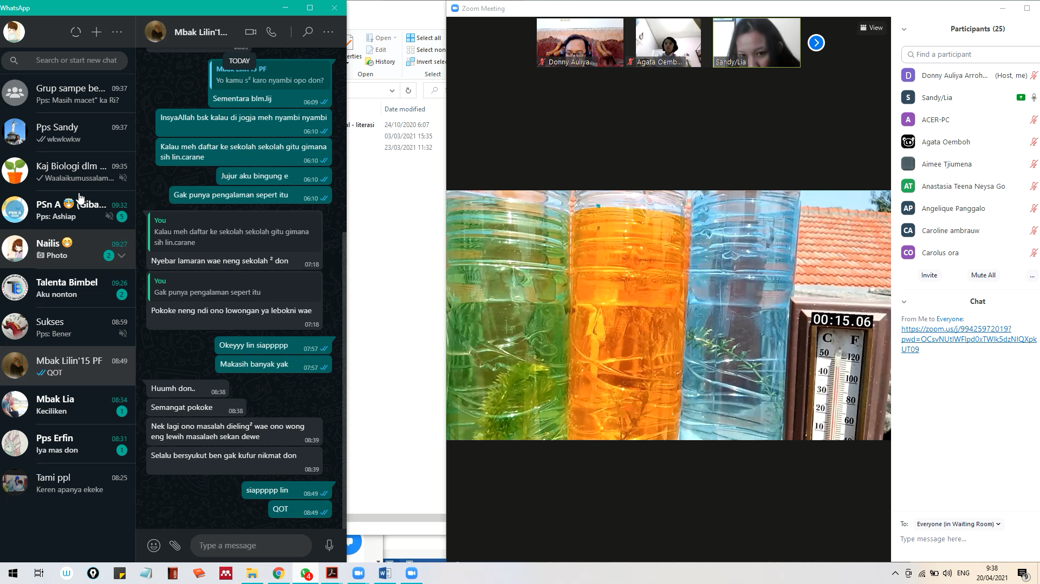
Figure 2. Observing the changes that occur in the measuring instrument and the bubbles in the bottle

Regarding the tools and materials shown in the video, students are able to identify and explain the uses of the tools and materials in the video, but based on interviews conducted, students still have not found and have never encountered Hydrilla aquatic plants, and some mention that it is for measuring thermometers. Hard to find around where they live. The use of the practicum video itself and displaying tools and materials as well as rare work will bring students to learn that it cannot only be learned at school but can also be studied at home. In other words, through the use of learning videos, students will find it easier to recognize and understand how the tools and materials in the video work, educators will find it easier to overcome the problems of finding tools and materials around the school environment.
The next qualitative data related to the work step procedure, students, explained that the work steps shown in the video were easy to understand and could be followed easily, but one of the students suggested that, if possible, in the video, reduce the use of long sentences. For the advantages conveyed by students regarding the photosynthesis demonstration video that has been shown, they are easy to understand every content contained in the video, attracting attention because they just understood and found that the bubbles that came out of the Hydrilla plant were the result of the photosynthesis process. Based on the results of the interview explained that the tools and materials, as well as the work steps in the video, were shown in full.
The use of language that is easy to understand in the narration is actually the main key to making students interested. Later, students will also easily understand the message conveyed in the video (Jundu et al., 2020). It is different when there is a term or language that is difficult for students to understand, they will automatically feel bored and find it difficult to understand the message they want to convey.
Another interest of students in learning videos is that they enjoy the back sound produced by the video. Indirectly this disclosure shows that students do not want to always listen to the narrative being discussed, but they also need to focus on what is observed to be analyzed and understood in depth so that their focus is on one observation and is no longer distracted by the narration that comes out in the video, but they enjoy the background sound.
Basically, when music is implemented in learning, it will affect brain waves and neurophysiology of the human body to obtain later positive results. These results will improve concentration, glue the memory of the subject matter, make one’s atmosphere more relaxed and happier, and the last one will make performance to get better test scores or tests (Fitroh and Khasanah 2016).
Novia et al., (2016) added that when music is used in learning, music will help students to be enthusiastic in learning material, and basically, music will make the left and right brains of students balanced so that the effect is to make someone easy to understand the material, the situation is more comfortable, does not experience a compulsion in learning material, and of course, makes learning more focused.

Conclusion

Research that has been carried out has shown that the use of photosynthetic practicum demonstration videos can improve students’ basic science process skills, namely aspects of observing, classifying, measuring, inference, predicting, and communicating. Through the application of demonstration videos using the online learning process, several obstacles were found, namely the instability of the internet network, insufficient time to conduct video conferencing, and there were some who experienced the video not running smoothly. Through the use of photosynthetic practicum demonstration video media, it is able to attract the attention of students to the processes that occur in it, such as the release of bubbles on the Hydrilla plant and the advantages generated through the use of photosynthetic practicum demonstration videos are that students can follow the learning process smooth and the video displayed as a whole can make students to better understand and understand the main content of the video.

Acknowledgments

Thank you to the leadership of the YPPK St. Junior High School. Don Bosco, Sorong, West Papua who has provided the facilities so that this research can be completed smoothly

References

